
Ras (Q61H)
Catalog Number: CR-M26195
Gene Symbol: RAS
Description: Anti-Ras (Q61H) Mouse Monoclonal Antibody

Background: Ras protein is a
membrane-associated GTPase signaling protein that regulates proliferation, differentiation, and cell survival. Ras Q61H mutation result in
decreased GTPase activity and constitutive
signaling, and is correlated with the development of pancreatic intraepithelial neoplasia and lung lesions.
Immunogen: A synthetic peptide from the internal region of Ras which includes the mutation of Q61H, human origin
Tested applications: ELISA, WB, IHC Recommended dilutions:
ELISA 1:100-1:5000
WB 1:100-1:2000
IHC 1:100-1:500
Concentration: 2 mg/ml
Host: mouse
Clonality: Monoclonal
Isotype: Unknown
Purity: Purified from ascites
Format: Liquid Storage buffer:
Preservative: no
Constituents: PBS (without Mg2+ and Ca2+), pH 7.4, 150 mM NaCl, 50% glycerol
Species Reactivity: Recognizes RAS (Q61H)
mutated, but not wild-type Ras proteins. proteins of vertebrates.
Storage Conditions: Store at -20°C. Avoid freeze / thaw cycles

Western blot:

Ras protein
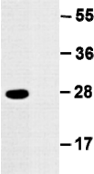

Western blot analysis of recombinant Ras WT
and Q61H proteins. Equal amount of purified Ras Q61H (lane 1) and corresponding wild type
protein (lane 2) were loaded and blotted with
anti-Ras Q61H mouse monoclonal antibody (Cat.
#26195).

For research use only. Not for diagnostic or therapeutic applications.

Immunofluorescence:

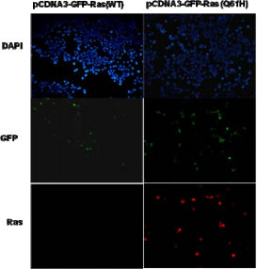

Immunofluorescence of cells expressing Ras (Q61H) protein with anti-Ras (Q61H)
antibody. HEK293T cells were transfected with pCDNA3-GFP-Ras (WT) plasmid (left column) or pCDNA3-GFP-Ras (Q61H) plasmid (right column), then fixed and stained with anti-Ras (Q61H) monoclonal antibody (Cat. #26195).

For research use only. Not for diagnostic or therapeutic applications.

科博瑞（武汉）生物科技有限公司
TEL：027-87615885 15972062685
- mail：3636901710@qq.com
Web:www.coburybio.com

